Take a mesh file and given a z coordinate, using matplotlib create a 2d plot of that plane, possibly using imshow. I will give you an example mesh file and some other info about the data. Perhaps install PyCharm and write it in Python.

You can read the mesh file using the meshio Python module, PyVista will help with defining a plane in the mesh and interpolating the data onto the plane. Use matplotlib to plot the data.

Here is information about a gmsh mesh file (version 2.2 format)
https://www.cfd-online.com/Forums/openfoam-meshing/178945-understanding-output-file-gmsh.html You don’t need to use gmsh, just the msh files. Mesh1.msh contains the mesh definition and the other files each contain a data set with a number at each node in the mesh.

The mesh file contains a list of tetrahedral meshes Here is a tetrahedron:
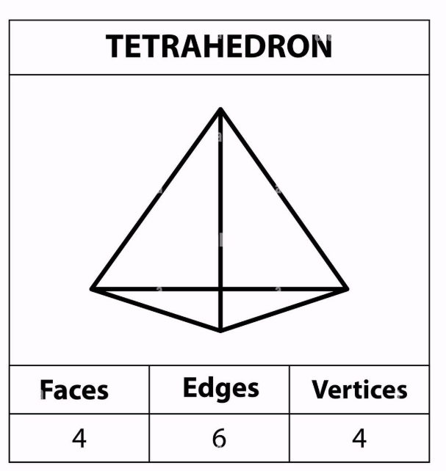
The geometry that we are looking at is filled with tetrahedrons. mesh1.msh gives the coordinates of all the vertices (or nodes) of each tetrahedron and info about how they are connected. I think the data is for the inside of each tetrahedron. The tetrahedrons that make up the geometry is called the mesh. It is unstructured, so you need to figure out the coordinates of the locations in the plane. The user inputs the z location and you can use given x and y coordinates in that z plane. You need the following info:
- Coordinates in the plane
- Mesh file with the mesh info
- Mesh data file which has the data for node in the mesh
You need to do the following. The Python modules I mentioned above should do most of the work for you.:
- Load and interpret the mesh file
- Load and interpret the data file
- Figure out the data values on the given plane
- Plot the data

